After initially running the executable file, you will be met with this opening screen.
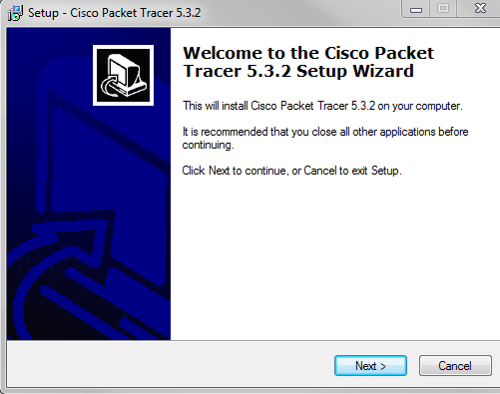

Press next and you will come to the Licensing Agreement.
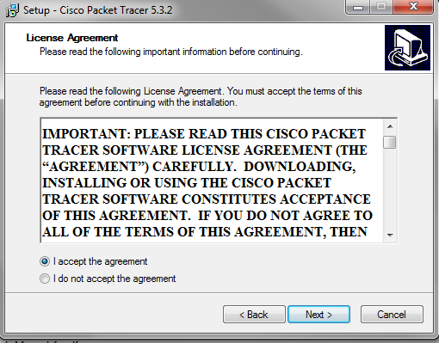

After agreeing to the Licensing Agreement and clicking Next, you will come to the screen that allows you to customize where your file will be saved. You will probably not want to install anywhere but the default. Click Next.
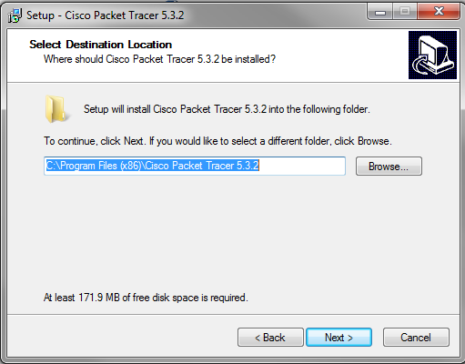
The default will save to a folder named Cisco Packet Tracer. If this is alright with you, press Next.
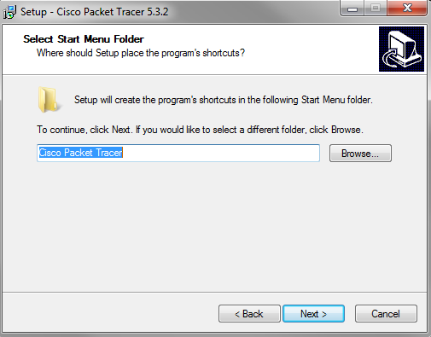
If you would like the Cisco Packet Tracer to add a desktop item or a Quick Launch icon, then select the box next to the preferred action(s) and click Next.
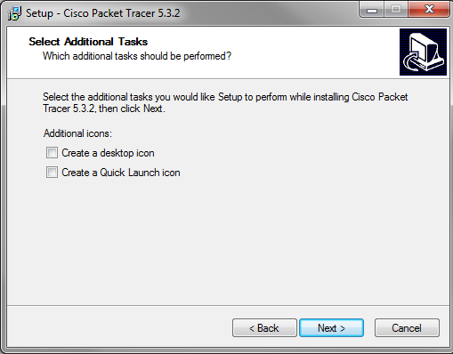
Click Install to begin installation, or Back to change your settings.
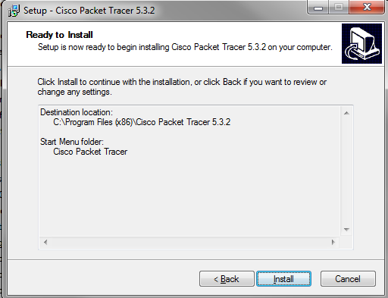
This is the view you will see while installation is being completed.
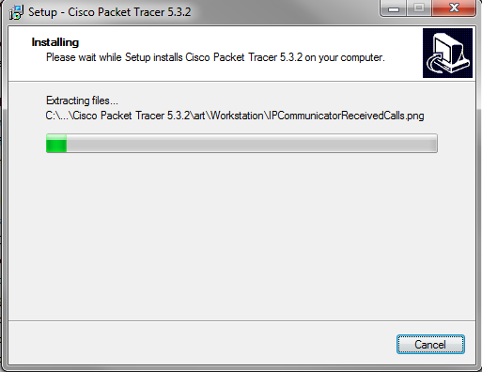
If all installs according to plan, this is the end screen. Select “Launch Cisco Packet Tracer” and then Finish to view the program you have just installed.
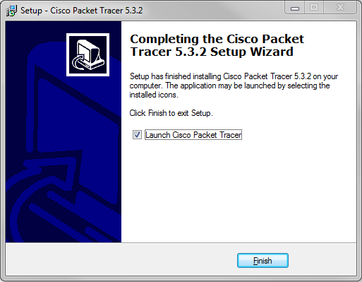
This is a guide to the starting screen of the Cisco Packet Tracer. The buttons have been labeled for your convienience.

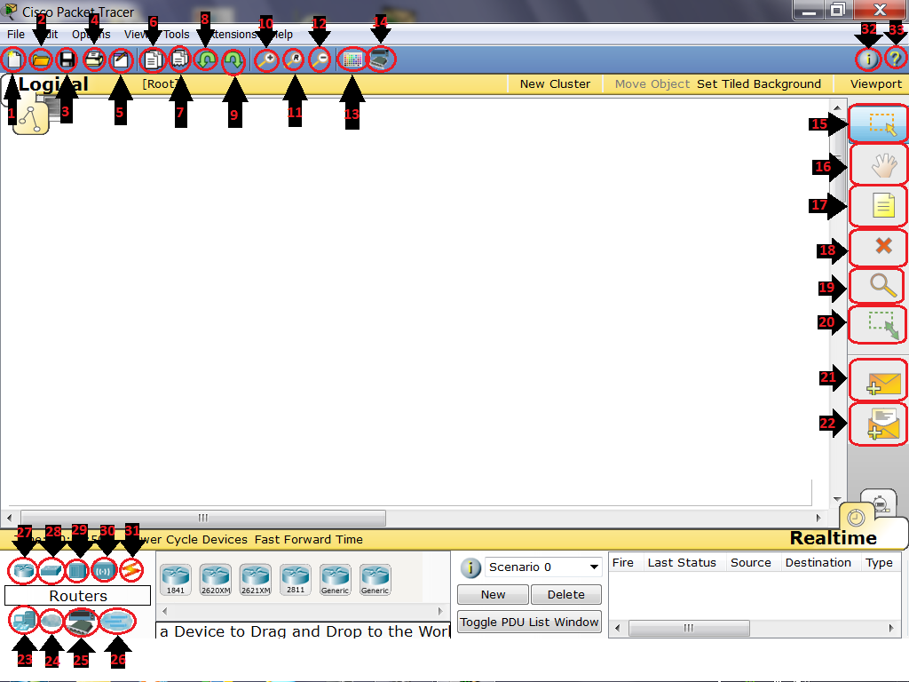

- New file
- Open file
- Save file
- Print
- Activity Wizard
- Copy
- Past
- Undo
- Redo
- Zoom in
- Zoom Reset
- Zoom out
- Drawing Palette
- Costume Devices Dialog
- Select
- Move Layout
- Place Note
- Delete
- Inspect
- Resize Shape
- Add Simple PDU
- Add Complex PDU
- End Devices
- WAN Emulation
- Costume Made Devices
- Multiuser Connection
- Routers
- Switches
- Hubs
- Wireless
- Connections
- Network Information
- Contents

